

Culture-Based Tourism Development Portal: A DigitalFrameworkforSustainableandCommunity- Driven Cultural Tourism
APROJECTREPORT

Submitted by
Rakshitha D P – 20221CSG0114 VishalGowdaH–20221CSG0116 SaiSiriNaiduO–20221CSG0124

Undertheguidanceof,
Dr.ChandrashekarV

BACHELOROFTECHNOLOGY

IN
COMPUTERSCIENCEANDTECHNOLOGY
PRESIDENCYUNIVERSITY BENGALURU
DECEMBER2025

I

PRESIDENCYSCHOOLOFCOMPUTERSCIENCEAND ENGINEERING
BONAFIDECERTIFICATE

Certified that this report “Culture-Based Tourism Development Portal:A Digital Framework forSustainableandCommunity-DrivenCulturalTourism”isabonafideworkof“RakshithaD P(20221CSG0114),VishalGowdaH(20221CSG0116),SaiSiriNaiduO(20221CSG0124)”,
who have successfully carried out the project work and submitted the report for partial fulfilmentoftherequirementsfortheawardofthedegreeofBACHELOROFTECHNOLOGY in COMPUTER SCIENCE AND TECHNOLOGY during 2025-26.

Dr.ChandrashekarV
ProjectGuide PSCS
PresidencyUniversity
Dr.SharmasthVali Program Project Coordinator
PSCS
PresidencyUniversity
Dr.SampathAK Dr. Geetha A School Project Coordinators PSCS
PresidencyUniversity
Dr. Anandaraj S P HeadoftheDepartment PSCS
PresidencyUniversity

Dr.ShakkeeraL Associate Dean PSCS
PresidencyUniversity

Dr. DuraipandianN
Dean
PSCS&PSIS
PresidencyUniversity

Examiners 1.
2.

PRESIDENCYUNIVERSITY

PRESIDENCYSCHOOLOFCOMPUTERSCIENCEAND ENGINEERING
DECLARATION

WethestudentsoffinalyearB.TechinCOMPUTERSCIENCEANDTECHNOLOGY,at Presidency University, Bengaluru, named Rakshitha D P, Vishal Gowda H, Sai Siri Naidu O, hereby declare that the project work titled “Culture-Based Tourism Development Portal: A Digital Framework for Sustainable and Community-Driven Cultural Tourism” has been independentlycarriedoutbyusandsubmittedinpartialfulfillmentfortheawardofthedegree of B.Tech in COMPUTER SCIENCE TECHNOLOGYduring the academic year of 2025-26. Further, the matter embodied in the project has not been submitted previously by anybody for the award of any Degree or Diploma to any other institution.

RakshithaDP USN:20221CSG0114

VishalGowdaH USN:20221CSG0116

SaiSiriNaidu O USN:20221CSG0124

PLACE:BENGALURU DATE:

ACKNOWLEDGEMENT
For completing this project work, we have received the support and the guidance from many peoplewhomIwouldliketomentionwithdeepsenseofgratitudeandindebtedness.Weextend ourgratitudetoourbelovedChancellor,Pro-ViceChancellor,andRegistrarfortheirsupport and encouragement in completion of the project.
IwouldliketosincerelythankmyinternalguideDr.ChandrashekarV,Professor,Presidency School of Computer Science and Engineering, Presidency University, for his moral support, motivation,timelyguidanceandencouragementprovidedtousduringtheperiodofourproject work.
IamalsothankfultoDr.Anandaraj,Professor,HeadoftheDepartment,PresidencySchool of Computer Science and Engineering Presidency University, for his mentorship and encouragement.
We express our cordial thanks to Dr. Duraipandian N, Dean PSCS & PSIS, Dr.Shakkeera L, Associate Dean, Presidency School of computer Science and Engineering and the Management of Presidency University for providing the required facilities and intellectually stimulating environment that aided in the completion of my project work.
We are grateful to Dr. Sampath A K, and Dr. Geetha A, PSCS Project Coordinators, Dr. SharmastVali,ProgramProjectCoordinator,PresidencySchoolofComputerScienceand Engineering,orfacilitatingproblemstatements,coordinatingreviews,monitoringprogress,and providing their valuable support and guidance.
We are also grateful to Teaching and Non-Teaching staff of Presidency School of Computer Science and Engineering and also staff from other departments who have extended their valuable help and cooperation.
RAKSHITHADP VISHALGOWDAH SAI SIRI NAIDU O

Abstract
Tourism in recent years has shifted from traditional sightseeing toward more immersive cultural experiences, where travellers seek meaningful engagement with local heritage, traditions,andcommunities.However,mostexistingdigitaltourismplatformsfocusprimarily on travel logistics, such as booking transport, accommodation, and basic itinerary planning. These systems often fail to provide opportunitiesfor deeper cultural interaction or community involvement. To address these gaps, this paper introduces the Culture-Based Tourism Development Portal, a holistic web-based platform designed to promote cultural heritage through sustainable and technology-driven tourism.
The proposed portal integrates tourists, local artisans, cultural organizations, and tourism boardsintoaunifieddigitalecosystem.DevelopedusingHTML,CSS,JavaScript,PHP,and MySQL, the platform ensures efficient front-end presentation, dynamic content management, and secure data storage.
Akeyfeatureofthesystemisitscontent-basedrecommendationmodel,whichanalyzesuser preferences—such as interests in traditional crafts, history, food, or festivals—to offer personalized cultural suggestions. This enhances user engagement by guiding them toward authentic experiences that match their interests. The platform also supports online cultural demonstrations, including virtual craft workshops, storytelling sessions, and live interactions withartisans.Thesenotonlyextendculturalaccessbeyondgeographicallimitsbutalsocreate new income opportunities for local communities.
Theresults ofpreliminarytesting indicate that the portal ismoreaccessible, user-friendly, and culturallyenrichedcomparedtoconventionaltourismwebsites.Itsemphasisonculturaldepth, personalization, and community involvement significantly improves user satisfaction. By combining modern technology with heritage preservation, the portal fosters responsible tourismpractices,empowerslocalartisans,andcontributestothesustainabledevelopmentof cultural destinations.

TableofContent

Sl. No. | Title | PageNo.
 | Declaration | III
 | Acknowledgement | IV
 | Abstract | VI
 | List of Figures | IX
 | List ofTables | X
 | Abbreviations | XI-XII
1. | Introduction  Background  NeedforCulturalTourismDigitization  ExistingTourismTechnologyLandscape  Problem Statement  SDGAlignment  OverviewoftheProjectReport | 1-5
2. | Literaturereview  ReviewofExistingCulturalTourismPlatforms  ResearchGaps  Objectives | 6-11
3. | Methodology  SystemDevelopmentMethodology(V-Model/SDLC)  DataFlowandUser FlowApproach  TechnologyStackJustification | 12-19
4. | Projectmanagement  ProjectTimeline  WorkBreakdownStructure  ProjectSchedule  Rolesand Responsibilities  RiskAnalysis  ProjectBudget  PESTELAnalysis | 20-26

5. | AnalysisandDesign  SystemArchitecture  UseCaseDiagram  UseCaseDescriptions  DataFlow Diagram  Activity Diagram  ClassDiagram  ER Diagram  DatabaseSchema  User Interface | 27-39
6. | System Implementation  Overviewofimplementation  FrontendImplementation(Html,CSS)  BackendDevelopment(PythonFlask)  DatabaseImplementation(SQLite)  Admin module implementation  SampleCodeScreenshots  Displaying culturecontent dynamically  Testingduringimplementation | 40-56
7. | Testing  TestingObjectives  Typesoftesting  TestCases  Bug report  ValidationTesting  UsabilityTesting | 57-62
8. | ResultsAnd Discussions  Resultsof theimplemented system  Discussions | 63-66
9. | ConclusionAnd Future Enhancements  Conclusion  Future Enhancements | 67-69

ListofFigures

FigureID | FigureCaption | PageNo.
Fig 4.3 | GanttChart | 22
Fig 5.3 | UseCaseDiagram | 30
Fig 5.4 | DataFlow Diagram | 31
Fig 5.5 | Activity Diagram | 33
Fig 5.6 | ClassDiagram | 35
Fig 5.7 | Entity-Relation | 36
Fig 6.2 | CodeSnippet | 41-51
Fig 6.6 | Website  UserPage  AdminPage  EditingandDeleting Operations | 52 -53
Fig 6.7 | CulturalWebsitedisplaypage | 54-55
FigA.8 | Github Repository | 55

ListofTables

TableID | TableCaption | PageNo.
Table4.4 | Rolesand Responsibilities | 23
Table4.5 | Risk Management  4.5.2 Risk Mitigation Strategies | 24
Table4.6 | Cost Estimation | 25
Table5.8 | DatabaseSchema(SQLLite)  TableAdmin  Tablecategories  Tablecultural_items  Festivals | 37
Table7.3 | TestCases  Admin login  AddCulturalEntry  DeleteCultural Entry  DynamicdisplayPage  NavigationTesting  DatabaseConnection | 59
Table7.4 | Bug Report | 60

Abbreviations

Abbreviation | FullForm
CBTDP | Culture-BasedTourismDevelopmentPortal
SDG | SustainableDevelopmentGoals
UI | User Interface
UX | User Experience
HTML | HyperTextMarkupLanguage
CSS | CascadingStyleSheets
JS/ JavaScript | Client-sideScriptingLanguage
API | ApplicationProgramming Interface
DB | Database
CRUD | Create,Read,Update,Delete
ERD | EntityRelationshipDiagram
DFD | DataFlowDiagram
UML | UnifiedModellingLanguage
SQL | StructuredQueryLanguage
SQLite | LightweightSQLDatabaseEngine
IDE | IntegratedDevelopmentEnvironment
CSS | CascadingStyleSheets
SDLC | SoftwareDevelopmentLifeCycle
V-Model | Verification&ValidationModel

UI/UX | UserInterface/UserExperience
CRUD | CreateReadUpdateDeleteOperations
HTTP | HypertextTransferProtocol
URL | UniformResourceLocator
Flask | PythonMicro-WebFramework
WBS | WorkBreakdownStructure
PESTEL | Political,Economic,Social,Technological,Environmental, LegalAnalysis
MVC | ModelViewController(conceptuallyusedinstructureddesign)
DBMS | DatabaseManagementSystem
SEO | SearchEngine Optimization
FP | FrontendPage
BP | BackendProcess
QoS | QualityofService
AI | ArtificialIntelligence(futureenhancement)
AR/VR | AugmentedReality/VirtualReality

CHAPTER1
INTRODUCTION

Introduction

Tourism has not only changed into a leisure-focused practice but has also become a multidimensional business, which promotes a cultural exchange, economic growth, and empowerment of the community. Cultural tourism is one ofthe segments of tourism that have beencentralintheconservationofheritage,advancementofcultureandlivelihoodsinthelocal area. However, its potential is not always realized, and many culturally rich areas cannot find anentrypointtotheglobalcommunitybecauseofthelackofwell-organizedandaccessibleas well as community-driven digital platforms.

Culture-BasedTourismDevelopmentPortal(CBTDP)isoneofthewebsiteswhichareusedto solve this problem, offering a web-based solution which presents regional cultural resources, suchasheritagesites,localart,cuisine,folklore,festivalsandindigenouscrafts.Thesystemis based on a full-stack development model of HTML/CSS/JavaScript (frontend) and Python Flask+SQLite(backend),whichallowstheseamlessnavigation,accesstotheinformation,and a chance to add some content in the system offered to the local communities.

Thechaptergivesabackground,currentlandscape,contextoftheproblem,sustainabilityfitas well as the outline of the report.

Background

The world has realized cultural tourism as an essential component of sustainable development which leads to cultural exchange and provides a source of income to the locals. The potential ofculturaltourismisgreatinthecountriesofsuchgreatdiversity asIndia. However,thereare numerous cultural resources that are not documented or digital.

Therecentresearchindicatesthatthereisagrowingpreferencetowardsauthentic,community- basedandexperience-basedtourismwherethetouristsareinterestedinmeaningfulexperiences and not sightseeing. This change requires the contemporary digital models that:

- Currenthigh-qualityandeditedculturaldata.
- Marketlocal artists,localfestivalsandheritage.
- Intermediatebetweencommunitiesandbridge tourists.
- Maintaintheintangiblecultural identityindigitalform.

The active development of ICT and web technologies allows building platforms that will interconnectculturalstakeholdersandinternationaltravelers.TheCBTDPisaproductofsuch need to digitalize and preserve cultural heritage via an organized, interactive and community- based digital portal.

CulturalTourismDigitizationRequirement.

Althoughthereistheemergenceofdigitaltourism,thecurrentplatformsprimarilytarget:

- Commercialtourism
- Hotelbooking
- Generalsightseeing

Nosingledigitalplatformexiststhatfocusesonculture-firstexperiences. Therefore, cultural tourism needs to be digitized to:
- Conserveculture withWeb archives.
- Marketlocaleconomiesthroughonline presence.
- Providetouristswithvalidculturalinformation.
- Offerliveinformationregardingfestivalsand events.
- Stopbeingreliantonuntestedtravelblogs.
- Ensure communities are given a chance to be directly involved in tourism promotion.

The digitization guarantees transparency, authenticity, and sustainability and enables the smaller cultural regions that are commonly undermined by the main tourist destinations.

CurrentTourismTechnologyLandscape.

There are a number of digital tourism tools, which do not serve the needs of cultural tourism completely:

GenericTourismPlatforms

MakeMyTrip, TripAdvisor, Cleartrip are platforms that provide travel-oriented information, but they are not very cultural.

Government Initiatives

Such websites as Incredible India offer cultural descriptions without being interactive, personalized, and involving communities.

TravelBlogsandVlogs

Frequentlyunconfirmed,uncoherent,andunorganizedcultural background.

StateTourism Portals

Mostofthemareobsolete, non-responsive,orhighlevel descriptions.

Gaps Identified:

      - Absenceofcommunity-based content.
      - Littleemphasisonlocalartisansandculture mediators.
      - Nocustom-madeculturalitineraries.
      - Lackofcentralplatformofheritage, food,art,storiesandevents.

Theseshortcomingsunderscorethefactthatthereisneedtohaveacomprehensive,interactive system that focuses on cultural identity.

ProblemStatement

Themajorityoftheculturalsitesdonothaveonlinepresencethatcan effectivelycapturetheir heritage, traditional activities and community based experiences. The current platforms lack a holistic, genuine, and interactive platform that significantly links cultural assets with tourists.

SDG Alignment

The objectives of the project directly agree with the following UN Sustainable Development Goals (SDGs):

SustainableDevelopmentGoal8:DecentWork&EconomicGrowth. Empowers craftsmen, entertainers, guides and local merchants.
Goal1:SustainableCitiesandCommunities. Furthering cultural and sustainable tourism.
Goal2:ResponsibleConsumptionandProduction. Promotes community and ethical tourism.
Goal3:Goal partnerships.

Bridgescommunities,touristsandculturalorganizations.

Goal 4: Decent work and Economic growth Empowersworkers,localvendorsandmore.
Thisalignmentwillguaranteethattheportaldoesnotjustmakeacontributionintermsof technology but also in terms of social and environmental contributions.

OverviewofProjectReport

Thisreportisdividedintoninedetailedchapters:

Chapter1 -Introduction

Describesthecontextoftheproject,problem,objectivesandSDGsrelevance. Chapter 2 - Literature Review

Offersadetailedreviewoftheliteratureonculturaltourismdigitalization,withgapsand opportunities.

Chapter3 -Methodology

Outlinesthemodelofdevelopment,theworkflowofthesystem,andthechoiceofframeworks. Chapter 4 - Project Management
Discussesschedules,riskassessment,andbudgetingrelyingonthesystematicproject management methods.

Chapter5 -Analysis&Design

Requirements,systemarchitecture,flowcharts,UI/UXdesignanddatabaseschema. Chapter 6 - Implementation
Thefrontenddevelopment,Flaskbackendprogram,APIdevelopment,andintegratingthe database with SQLite is described.

Chapter7 -Evaluation &Results

Presentstests,testoutcomes,anduserassessmentmeasures.

Chapter8-Social,Legal, Ethical,SustainabilityandSafety Aspects.

Takesaboutthelargerramificationsofthedevelopmentandimplementationoftheportal. Chapter 9 - Conclusion
Concludesonthegeneralaccomplishments,constraintsandthescopeofthe future.

CHAPTER2
LITERATUREREVIEW
Cultural tourism is an interdisciplinary experience that entails heritage conservation, community involvement, digital revolution, user experience design, and sustainable development. In the last ten years, there has been a lot of research with regard to the impact that digital platforms have on tourism behaviour, cultural engagement, and heritage conservation.Inthischapter,theauthorhasgivenathoroughreviewoftheliteratureavailable on the fields that are pertinent to the (CBTDP) Culture-Based Tourism Development Portal creation. The review summarizes the research results conducted on the digital tourism systems, cultural preservation tools, community-based tourism, as well as on full-stack technological solutions to the development of tourism portals.According to the review, the research gaps are noticed and the project objectives are developed.
Theliterature analysisconsistsofareviewoftheexistingmodelsandresearchonthis topic.

ReviewofExistingModelsand Research.

CulturalTourismBasedandTrends.

Richards,2018-1-CulturalTourism:AReviewoftheRecentResearchandTrends.

Richards gives an extensive discussion of the manner in which cultural tourism has changed to be more active and participatory instead of a passive consumption of heritage by the tourists and the host communities. He points out that tourists are more demanding authentic, participatoryculturalexperiences.Thepaperemphasizesthesignificanceofaccessibilityand value creation in common.
Shortcoming:Lackstechnologicalintegration;nocommentaryonhowdigitaltechnologiesor AI can be used to improve cultural tourism engagement.

Urry&Larsen,2011--TheTouristGaze3.0

It is based on this sociological work that presents the ways in which the traveling person develops meaning based on the focus on what is referred to as the tourist gaze, which is influencedbyculture,mediaandtheglobalizationprocess.Itbringsouttheperceptionsof cultural spaces and experiences among tourists.

Limitations:Despitehavingahighlyrichtheoreticalbase,thestudyfailstomentiondigital transformation and how new platforms can redefine the tourist gaze in a digital era.

CulturalTourismDigitalization.

SmithandRobinson,2019-CulturalTourisminadigitalworld.

Thisessay discusseshow cultural tourism hasbeen transformed asaresult of thefast digital revolution. The digital platforms increase accessibility, user-generated content, and online promotion.Theauthorsclaimthatusercentereddesign,multimediamaterial,andinteractive story telling are all important in cultural learning.
Limitations:FailstodiscussAIoranalytics-basedpersonalizationandalsobrieflydiscusses the issue of privacy but does not provide solutions.

Tangetal,2024-DigitalTransformationinCulturalTourismEnterprises.

Theauthorspointouttheimpactofdigitaltransformationonthecompetitiveness,operational efficiency,andqualityofculturalexperienceoftourismbusinesses.Suchtechnologiesasdata analytics, mobile apps, and digitalized cultural resources reinforce visitor interactions.
Limitations:Concentratesonbusinesses,andnot community-basedculturalecosystems.

Cuomoetal.,2021--DigitalTransformation&Co-DesignedTouristExperiences.

Thisresearchpaperisdevotedtoco-designmethodsindigitalexperiencesinthecontextof which tourists and cultural stakeholders co-create digital experiences. It focuses on digital storytelling, user interaction and interface.
Limitations:Doesnotestablishthebarrierstoimplementationofruralcommunitieswith poor digital skills.

TourismBehaviouralandexperiencedesign.

Tussyadiah,2018-Technology&BehaviouralDesigninTourism.

The paper examines the nature of behavioural design, psychology and technology in influencingtouristdecision-making.Itemphasizestheneedofimmersivesettingsinorderto enhance the experience of cultural tourism.
Limitations:Failstodiscussdynamicuserpreferencemodel-basedadaptiveAIsystemsor methods of automation.

Community-basedCulturalTourismPlatforms.

Maqueraetal.,2022--Community-BasedTourism(Peru)IntelligentDigitalPlatform.

TheresearchintroducesanonlineplatformbetweentheSMEs,guidesandthetouristsinabid to market rural community tourism. The local actors become visible, and this leads to sustainable economic development.
Limitation:Lackscustomization,multi-linguistic,andartificialintelligence-based recommendation systems.

Chengcai,2024.DigitalCulturalTourismtoRevitalizetheRural.

Theresearchpaperevaluatestheuseofdigitaltoolstoreviveruraltourism,usingthesupport of local art, culture, and traditional livelihoods. Illustrates how the internet is important to market rural destinations.
Limitations:Principallyconceptual;doesnothavetechnicalarchitectureordesignmodels.

Sandriesteretal.,2025--DigitalTransformationandCulturalHeritageonthePeri- regions.
This study examines the role of digital technology in heritage conservation and sustainable regionaldevelopmentinlowvisitationregions.Showsthatdigitizationcanleadtoadecrease in cultural marginalization.
Limitations:Doesnotproposeastructuredsystemdesignsuitableforfull-stackweb applications.

RecommenderSystems,AI&HybridModels.

Chalkiadakisetal.,2023HybridRecommenderSystemofCulturalPointsofInterest.

Suggeststhatahybridartificialintelligenceframeworkshouldbeadoptedthatusesboth Bayesian inference and content based filtering to suggest cultural attractions. Enhances cultural suggestions relatedness and heterogeneity.
Limitations:Advanced,lesstransparent,andrequiringusersensitivedata,whichincreases the privacy concerns.

Solano-Barlizaetal.,2024--RecommenderSystemsinTourismIndustry.

An in-depth overview of the fact that recommender systems are highly beneficial as they enhancetheengagementofthetouristsandtheirsatisfactionratesthroughtheanalysisoftheir preferences and behaviour patterns.
Limitations:NotesThenotesrestrictedtheuseofAI-poweredsystemsinculturaltourismas other commercial tourism industries did.

Generosietal.,2025--WebTourismRecommender-basedPlatformintheInland Tourism.
Theworkpresentsaplatformthatwillfacilitatethemarketingoflesser-knowndestinationsin terms of preference-based recommendation logic and user profiling. It emphasizes the importance of recommender systems in marketing the non-mainstream destinations.
Limitations:Narrowsdowntodestinationpromotion,andisnotholisticallyrepresentativeof the culture e.g. food, festivals or crafts.

Arregoces-Julioetal.,2025--FlexibleProfile-BasedCulturalTourismRecommender System.
Proposesanadaptablerecommendermodeltothenewculturaldestinations.Thesystemis flexible enough to adjust to the changing user preferences through profile-based filtering.
Limitations:Notabletoincorporatecommunity-createdcontentormultilingualcultural background.
ImmersiveTechnologies:VR/ARinCulturalTourism2.1.6.

Yinetal.,2024--VR/ARCulturalHeritageLearning.

The analysis of VR/AR-based virtual heritage tours is aimed at increasing the cultural learningprocessandaccessibility.Showsthatimmersivesettingspromoteculturalawareness and diversity.
Limitations:Expensivetoimplement,requiresadevice,andpotentialprivacyissuesthatthe data might have during the tracking process.

Mengetal.,2021-meaning-awareculturalnavigation system.

Presentsanavigationsystemthatcombinessemanticanalysistodirectthetouristsincultural attractions on the basis of meaning and context.
Limitations:Needshugevolumesofsemantics,andcannotbeeasilyadaptedtosmaller areas.
TourismRecommenderSystemstoSocialInclusion.

Gasparetti&Micarelli,2021--TourismRecommenderSystemstoSocialInclusion.

Illustrateshowtherecommendersystemscanenhanceaccessibilityandinclusivenessby allowing the marginalized groups to become cultural contributors.
Limitations:Lacksimplementationmodelsondevelopingcountrieswithlessertechnical infrastructure.

ResearchGapsIdentified

Accordingtotheresearchmentionedabove,thefollowinggapscanbedistinguished:

Absenceofa centralizedculturaltourismplatform.

Thereisnosystemthatcombinestheculturalheritage,festivals,stories,food,artand community contribution in one interface.

Inadequatecommunityinvolvement.

Thelocalcommunitiesarenotinapositiontoenterorcontroltheculturalinformationinmost digital platforms.

LackofAI-basedculturaldata personalization.

Thecurrentrecommendersystemsaretargetingmainstreamtourismorareculturallyshallow.

Absenceofvibrantandreal-timeupdatesofcultural events.

Majorityof theportalsarebased onthe static content andnot thedynamicdatabases.

Issuesofaccessibilityand multilingual.

Existingplatformsarehardlyruralormultilingualintermsofculturalrepresentation.

LittleimmersiveVR/ARmoduleintegration.

Researchindicatespotentialbutplatformscannotputthemintogoodpracticebecauseofcost and technical difficulties.

Thelackofdigitalrecordsonintangiblecultural heritage.

Culturalaccounts,folklore,rituals,craftsandoral historiesarestillunderrepresentedonline.

ObjectivesoftheProposed System

Inlinewiththeliteraturefindings,theCulture-BasedTourismDevelopmentPortalobjectives can be identified as:

Todevelopafull-scaleelectronicinfrastructureofculturaltourism.

Combininghistoricalattractions,festivals,cultures,foodandarts.

TocreateawebportalwithFlaskandSQLiteasafullstack.

Scalabilityandassuranceofdynamiccontentmanagement.

Toallowcommunityinvolvement.

Thecontentcanbeaddedormodifiedbythelocalartisans,culturalorganizations,andthe community members.

Toaddindividualizationcharacteristics.

Suggestionsrulestofindacommongroundbetweentheuser andculturalinterests.

Toenhancesustainableandinclusiveculturaltourism.

- Investinginsmalltownsandthe economy.

Inorderto improveoncultural learning.

Withthehelpofmultimediagalleries,stories,andinteractiveparts.

Inorderto haveeasy navigation,responsivedesign, andreliable data.

- Offeringaneffectiveplatformtothetouriststoexploretheoriginalcultural experiences.

CHAPTER 3 METHODOLGY
Culture-Based Tourism Development Portal (CBTDP) is constructed in a systematic and structured approach in order to be accurate, usable, and scalable. The approach will integrate software engineering concepts and user-focused design approaches to provide a powerful, interactive, and community-based cultural tourism service. The chapter describes the development strategy, flow of work, system workflow, architecture, as well as technologies employed.Consistentwiththecapstoneformat,theV-Modelischosenasthe maindevelopment approach because it is clear, sequential, and highly focused on testing and validation at each phase.

DevelopmentMethodologyofV-Model.

AverypopularsoftwaredevelopmentmethodologyistheV-Model(VerificationandValidation model), which is appropriateto usewhen working on academicand professional projects with tight documentation, testing, and review cycles.

TheReasonV-Modelwasselectedinthisproject?

- Offersawell-organizedandstringentdevelopmentcycle.

- Assuresateach stageof testing.

- Fitswithfull-stacksystemsonthefrontandtheback side.

- Helpstocopewithrequirements predictably.

- Fitsinwithscholarlyprojectrequirementsandthosethatinvolvealotofdocumentation.

V-ModelStagesusedinthisproject.

- RequirementsAnalysis(Checking)

Duringthisstage,non-functionalandfunctionalrequirementsoftheportalweredetermined. Examples include:
  - Exhibitingculturalsites,festivals,foodand art.

  - User-friendlynavigation

  - Admincontent management

  - Securityofstoreddata

  - Mobile-responsive UI

Therequirementswereobtainedbasedon:

  - Literaturereview findings

  - Community needs

  - Culturaltourismstandards

  - Bestpracticesoftheuserexperience.

SystemDesign

Systemdesignwasdone inhigh-levelarchitecture,andit included:

  - Webarchitectureworkflow

  - Frontend-backendcommunication.

  - Databasestructure (SQLite)

Modular Flask-based router backend: The router supports a routing approach that is modular andcanbeextendedandmodifiedtomeetspecificapplicationneeds.<|human|>ModularFlask- based router backend: The router is based on a routing model that is modular and can be expanded and customized to suit specific application requirements.
This was aimed at making sure that it was scalable, low in complexity and the code can be reused.

ArchitectureDesign

Inthiscase,specificdesignchoiceswere selected:

  - DataFlow

  - Functional components

  - Databaseschema(ERD)

  - Pagestructure anduserinterface/experience.

  - RESTAPIendpoints design

Thisactiondeterminedthequalityofinteractionofeachmodule withtherestofthesystem.

Module Design

Eachofthemajormoduleswasdesigned separately:

  - User Interface Module CulturalInformationDisplayModule
|human|>CulturalInformationDisplay Module.

  - Festival&EventModule

  - FoodandArtListing Module

  - AdminManagementModule

  - Structurethatisreadyto berecommended.

Eachmodulewasmadeto standaloneso thatit could bedebugged easilyand also scaled.

Implementation(Coding)

Realdevelopmenthasbeendone using:

  - JavaScript,Bootstrap,CSS,HTMLfrontend.

  - Python Flask for backend

  - SQLitefor database

  - Jinja2 in dynamic templating.

  - Flaskrouting ofnavigation.

Eachofthemoduleswasdesignedbasedonthespecificationsofthedesignintheprior stages.

UnitTesting(Validation)

Allthemodulesweretested separately:

  - Pagerenderingtests

  - APIendpointtests

  - DatabaseCRUDoperations

  - Inputvalidationtests

Themajorityoftestswereperformedonthelocalserver thatwasbuiltintothe Flask.

IntegrationTesting

Testingwasdoneontheabilityofmodulesto interact:

  - Frontend↔Backenddataflow

  - Flask–SQLite interactions

  - IntegrationoftheAdmindashboard.

  - Diversificationoffigures,imagesandmultimedia loading.

Thismadethesystemactinamanner thatwasdesiredontheentire platform.

SystemTesting

Fullsystemvalidationwasdoneto ensure:

  - Navigation correctness

  - Pageload efficiency

  - Reactivityacrossscreensizes.

  - Data accuracy

  - Securitycomplianceand error handling.

Deployment/UserAcceptanceTesting.

Thefinalstageinvolved:

  - Locatingthesiteeither locallyorina cloud.

  - Lookingatthefeedbacksofsample users.

  - Checkingtheculturalcontentvalidity.

  - Measuringtheworkfloweffectivenessoftheadministration.

Thefeedbackofusershelpedtomakeminoradjustmentstoenhanceexperienceand accessibility.

SystemWorkflow

Theworkflowexplainstheinteractionbetweentheportalandthetouristsandtheadmins. User Workflow (Tourist)
- UserlandsonHomePage

- Surfscultural(Art,Heritage,Food,Festivals,Events)categories.

- Clicksonsingleculturalpages.

- Viewsprovideinformation,pictures,descriptionsandmeaning.

- Searchingoptionallybyculturespecificsearch.

- Practiceswithmediaorotherrelated materials.

AdminWorkflow

- Adminlogsin

- Enhancesoraddscultural content.

- Organizeseventsand festivals.

- Postsphotographsand texts.

- Approves/reviewsdata

- WriteschangestoSQLitedatabase.

DataFlowoftheSystem
Theoverallflowthatisupheldthroughouttheportalisthefollowing: Step 1: User Request (Frontend)

Userclicksanitemorapageintheculture,HTTPrequestissent. Step 2: Flask Backend Processing.
Requesttoflaskisreceivedbytheflask,whichidentifiestheroute,andretrievesthenecessary data.
Step3:DatabaseAccess

SQLiteDBwasusedtoqueryculturalinformation,events,foods,crafts,etc. Step 4: Response Generation
PreparesJinja2templateinflask—insertsthedatabasecontentinthetemplate. Step 5: Response to User
Pageisdynamicintermsofculturalcontentandimages.

SystemArchitecture

Thesystemarchitectureisathree-layered system:

- PresentationLayer(Frontend)

  - HTML5/CSS3

  - Bootstrap

  - JavaScript

  - ResponsiveUI

  - Thepagesoftheuserinterface(Home, Culture,Events,About Us).

- ApplicationLayer(Backend)

  - Python Flask

  - Routing system

  - API endpoints

  - Templates

  - Validationandprocessingofcontent.

- DataLayer(Database)

  - SQLite database

Tablesonheritageplaces,festivals,foods,artforms, events.

  - Admin tables

  - Imagereference tables

The architecture can be maintained, scaled, and enhanced in the future, such as recommender system or analytics.

TechnologyStackJustification.

Backend–PythonFlask

- Lightandnon-integrityrisky.

- Academicandproductionsystems appropriate.

- Lowlevelofconfiguration required.

- Jinja2supportsdynamicHTMLgeneration.

- Outofthe box support to SQLite.

Database– SQLite

- File-based,easyto deploy

- Quickfastenersonapplicationsofreadiness.

- Lightweightculturaltourismsystems.

Firstly, zero configuration was needed. FrontendHTML,CSS,Bootstrap,Javascript.
- Enhancesuserexperience

- Fasterdevelopmentcycle

- Offersmobileresponsivedesignsto tourists.

DevelopmentToolsUsed

- VSCode– main IDE

Theserver canbea flaskdevelopmentserver thatisusedto test locally.

- SQLiteBrowser-database visualization.

- GitHub– version control

- Figma–UI/UX design

Summary

V-Model made sure that the Culture-Based Tourism Development Portal had a structured process of development and testing. The process was facilitated with the methodology of a structuredrequirementcollection,architecturaldesign,modulardevelopment,testinginphases and smooth integration. The portal provides a community-driven, scalable and inclusive cultural tourism solution by integrating user-centered design and full-stack development practices.

CHAPTER4
PROJECTMANAGEMENT
GoodprojectmanagementwouldmakesurethatCultourism.PortalofCulture-BasedTourism. isbuiltinasystematicmannerandwithintheallocatedtime,scopeandresources.Thischapter includesplanning,organization,monitoring,andcontrollingmethodsduringthelifecycleofthe development process. It contains the scope of the project,Work Breakdown Structure (WBS), schedule (Gantt chart), team roles, risk analysis, cost estimation and PESTELanalysis. These tools also facilitate effective coordination, delivery and generally quality of the system.

ProjectScope

Thescopeoftheprojectestablishesthe scope,functionalityand deliverablesoftheportal.

In-ScopeActivities

- Flask(Backend)andHTML/CSS/JS(Frontend)Full-stackdevelopment.

- SQLitedatabasedevelopmentand implementation.

- Contentmanagementadministrationmodule.

- Viewingmoduleofculturaldata.

Categoriesofculturalcontent(Food,Heritage,Art,Festivals).

- Dynamicweb site.

- Testing,documentationanddeployment.

Out-of-ScopeActivities

- RecommendersystemsthatarebasedonAI(enhancementinfuture)

- VR/AR immersive modules Themultilingualtranslationengine.
- Mobileapplication(justwebversioncreated)

WorkBreakdownStructure(WBS).

Theprojectisdividedintomanageabletasksandisrepresentedbythe WBS:

Level1:ProjectTitle

Culture-BasedTourismDevelopmentPortal

Level2&Level3 Breakdown

- Planning

- 1.1Requirementsgathering

- 1.2Literature review

- 1.3Feasibility study

- 1.4Technologyselection

Design

- 2.1Systemarchitecturedesign

- 2.2Databaseschema (ERD)

- 2.3UI/UX design

Flowchartsanddataflowdiagrams2.4.

Development

- 3.1Frontenddevelopment

- 3.1.1 Homepage

- 3.1.2Culturepages

- 3.1.3Events&Festivals pages

- 3.1.4About&Contact pages

- 3.2Backenddevelopment (Flask)

- 3.2.1 Routing

- 3.2.2Admin module

- 3.2.3CRUDoperations

- 3.3SQLitedatabase development.

Testing

- 4.1 Unit testing

- 4.2Integration testing

- 4.3 System testing

- 4.4Useracceptance testing

Deployment

- 5.1Serversetup(local/cloud)

- 5.2 Final deployment

- 5.3Backup&documentation

Documentation

- 6.1Report preparation

- 6.2Finalreview&formatting

- 6.3Presentationslides

ProjectSchedule(GanttChartRepresentation)
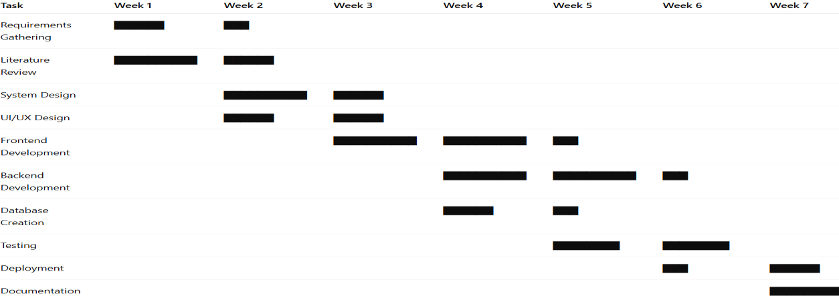

RolesandResponsibilities

Role | Responsibilities
ProjectManager | Scheduling, planning, monitoring progress,  resourceallocation
SystemAnalyst | Requirementanalysis,feasibilitystudy,workflow  design
Designer(UI/UX) | Screenlayout,userinterface,wireframes,colour scheme
BackendDeveloper | Flaskroutes,serverlogic,integrationwithDB
Frontend Developer | HTML/CSS/JS pages, responsiveness, visual  elements
DatabaseEngineer | SQLiteschemadesign,CRUDoperations,data  security
Tester | Unit&integrationtesting,bugreporting
DocumentationLead | Report preparation, formatting, diagrams,  Appendices
RiskManagement

RiskManagementtable

Risk | Category | Impact
Requirementchanges | Technical | Medium
Timeconstraints | Schedule | High
Bugs/Errorsincode | Quality | Medium
Bugs/Errorsincode | Quality | Medium
Databasecorruption | Technical | High
Lack of cultural content  availability | Resource | Medium
Versionconflicts | Technical | Low
Deploymentfailure | Operational | Medium

RiskMitigationStrategies

Risk | MitigationApproach
Requirementchanges | Finalizerequirementsearly&documentscope clearly
Timeconstraints | Maintainweeklymilestones& buffers
Bugsincode | Regularunittestingandpeer review
Databaseissues | Usefrequentbackups&validationrules
Lackof content | Collectcontentfrommultiplesources&publicdata
Versionconflicts | UseGit forproper version control
Deploymentfailure | Testdeploymentlocallybeforefinalhosting

CostEstimation

Although academic projects do not incur commercial cost, a hypothetical cost model is often required to keep a check on the cost.

EstimatedSoftware&ResourceCosts

Item | Cost(INR)
Laptop/DeviceUsage | 10,000 (depreciation)
Software Tools (VS Code,  SQLite) | Free
InternetUsage | 2,000
HostingSetup (optional) | 1,000
DesignTools(Figma/Canva) | Free/500
Miscellaneous | 1,500

PESTELAnalysis Political Factors
- Governmentculturalpoliciessupportheritagepreservation.

- Tourismregulationsimpactcontentauthenticity.

- DigitalIndiainitiativespromoteonlineculturalplatforms.

EconomicFactors

- TourismcontributessignificantlytonationalGDP.

- Digitalplatformsreducemarketingcostsforruralartisans.

- Economicdownturnsmayaffecttourism activity.

SocialFactors

- Increasinginterestinculturalexperiencesandlocaltraditions.

- Communityinvolvementimprovescultural preservation.

- Awarenessofsustainabletourismisrising.

TechnologicalFactors

- Growthofwebtechnologies,Flaskframeworks,databases.

- Smartphonesincreaseaccesstocultural portals.

- Potentialfor futureexpansionusingAIandAR/VR tools.

EnvironmentalFactors

- Reducedphysical explorationthroughdigitalalternativeslowersenvironmentalimpact.

- Culturaltourismencouragesresponsibletravelpractices.

LegalFactors

- Needcompliancewithdataprivacylaws (ITActofIndia).

- Copyrightconsiderationsforculturalimages and narratives.

- Licensingforculturalcontent usage.

ChapterSummary

This chapter presented a comprehensive project management strategy for the Culture-Based Tourism Development Portal. Using structured planning tools such as WBS, Gantt Charts, riskassessments,andPESTELanalysis,theprojectwasexecutedinanorganized,controlled, and efficient manner. These management practices ensured timely completion, quality development, and alignment with system goals.

CHAPTER5
SYSTEMDESIGN

The system design serves as a roadmap to the whole Culture-Based Tourism Development Portal.Itspecifiesthewaythesystemwillrun,themannerinwhichthepartswillinteract,the movement of data across the platform and how the users interact with the interface. This chapter presents the structural, behavioural and architectural models in detail by use of industry standard diagrammatic models like UML diagrams, DFDs, ER diagrams and workflow models. This is aimed at making the system pre-implementation and in the implementation process, clear, modular and scalable.

SystemArchitecture

Culture-BasedTourismDevelopmentPortalhasthethreetierarchitecturethatinvolves presentation layer, logic layer, and data layer.

PresentationLayer(Frontend)

  - TheworkisbasedonHTML,CSS,Bootstrap,JavaScript.

  - Giftsculturaldata(heritagesites,festivals,art forms,andso on)

  - Dealswithuserinteraction,responsivenessandnavigation.

  - ThereareHome,CulturalListings, Festivals,Food,andAdminDashboardpages.

ApplicationLayer(Backend)

PythonFlaskwasusedtodevelop it.

  - Dealswithrouting,sessionprocessinganddataprocessing.

  - rendersJinja2 templates.

  - Checksinputandgetsintouchwiththe database.

DataLayer (Database)

SQLitedatabaseincludesallculturalinformation.

  - Includestablesfor:

- Heritage_Culture

- Festivals_Events

- Art_Forms

- Food_Culture

- Admin

- Images

Itisanarchitecturethatallowsdevelopinginamodularway,updatingitmorequickly,and maintaining it with ease to provide a seamless cultural tourism experience.

UseCase Diagram

PrimaryActors

- Tourist/User

- Admin UserUseCases
Description:Thelearner isexpectedtobe abletoperceiveCulturalInformation.

- UC2:ViewFestivalsand Events

- UC3:SearchCultural Content

- UC4:ExploreFoodandArt

UC5:BrowsingthroughDetailedCulturalDescriptions. Admin Use Cases
- UC6: Login

- UC7:Add Cultural Entries

- UC8: Edit Existing Entries

- UC9:Delete Entries

- UC10:Upload Images

- UC11:OrganisingEventsandFestivals.

UseCase Descriptions

UC1:SeeCulturalInformation.

- Actor:Tourist

Description:Theuserisexposedtoculture-specificsites,includingheritagesites,arts, cuisine, and festivals.

- Output:Showsappropriateculturalinformationthatwasaccessedinthedatabase.

UC6: Admin Login

- Actor: Admin

- UsernamesandPassword: Inputs.

- Operation:Authenticate withFlaskbackend.
/*Result:Accesstothedashboardoftheadministrationisobtained. UC7: Add Cultural Entry

- Actor: Admin

- Precondition:Adminisloggedin.

- Process:Adminwillenterculturaltitle,description,category andimage path.

OutcomeThenewculturalentryhasbeenstoredinSQLite. UC9: Delete Entry
- Actor: Admin

- Action: Click on entry deletion Output:Removalofoutcomeofthedatabase.

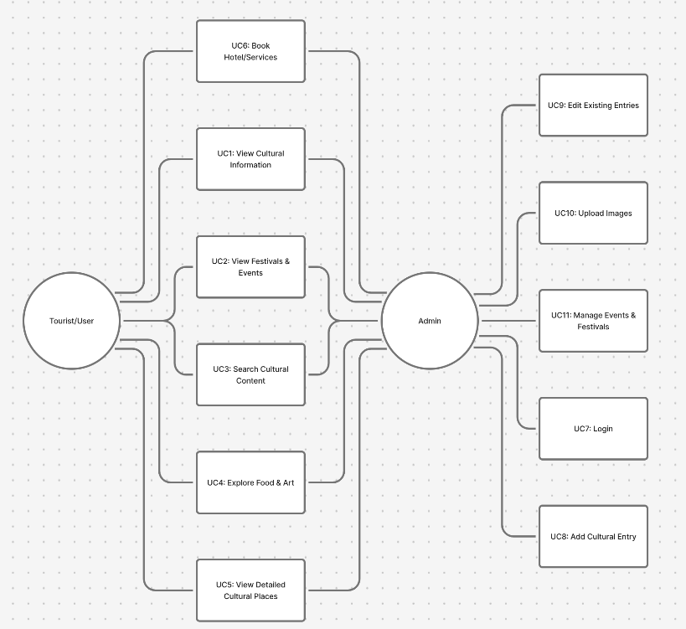

DataFlowDiagrams (DFD)
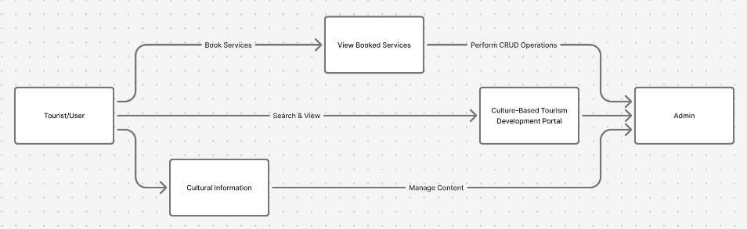

DFDLevel0(ContextDiagram)
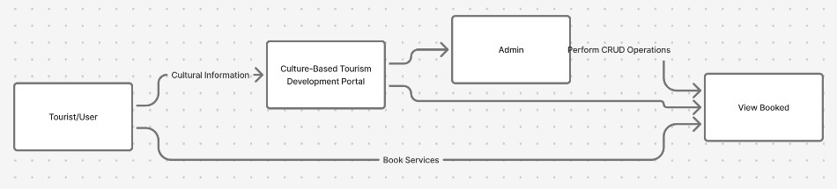

DFDLevel1

Main Processes

- UserInterfaceInteraction

- CulturalDataRetrieval

- AdminAuthentication

- Content Management

- DatabaseProcessing
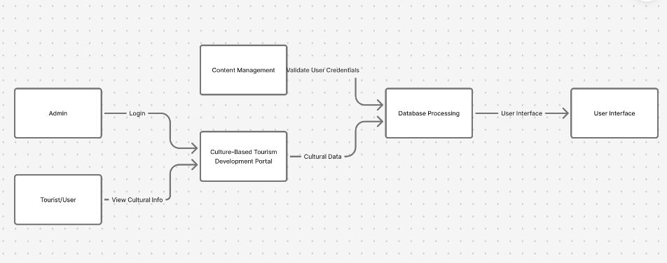

Flow
User→UI →FlaskBackend →Database→ UI

ActivityDiagrams
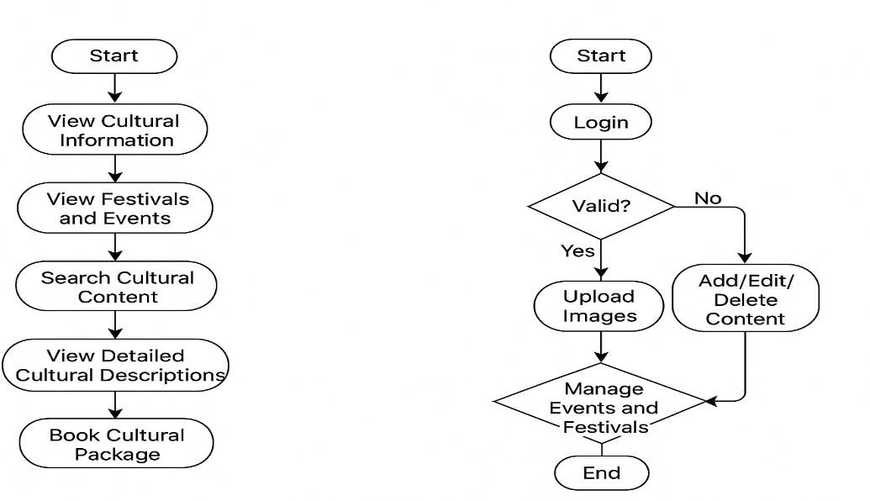

UserBrowsingActivity

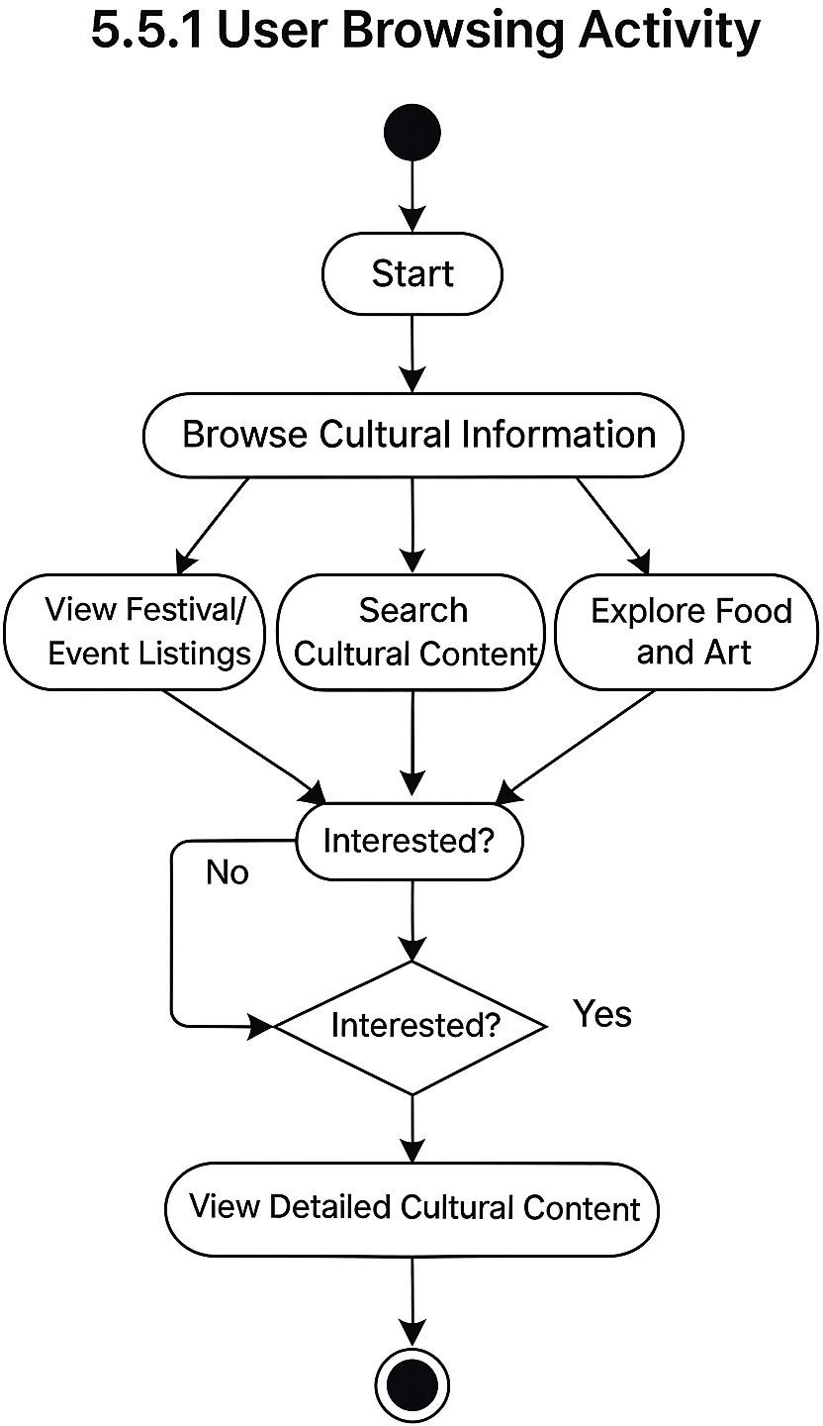

AdminManagementActivity

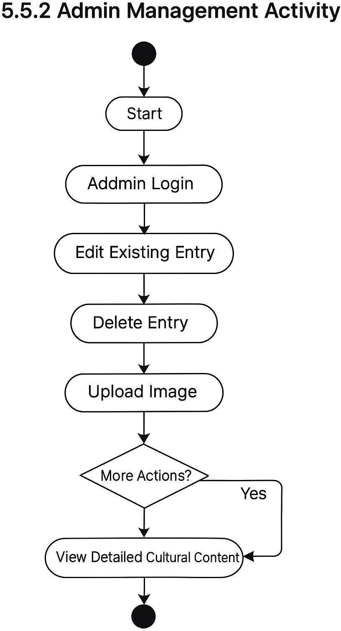

ClassDiagram(UML)
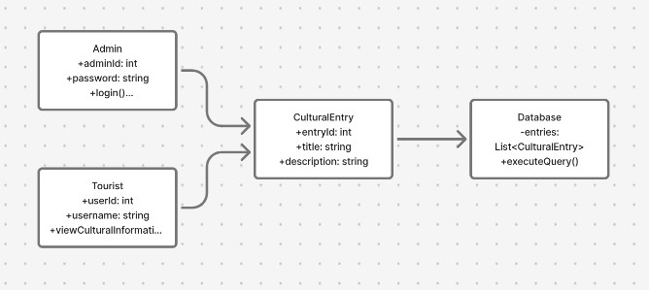

ER(Entity–Relationship)Diagram Entities
- Admin

  - Admin_ID

  - Username

  - Password

- Cultural_Item

  - Item_ID

  - Title

  - Description

  - Category_ID

  - Image

- Category

  - Category_ID

  - Category_Name(Heritage/Food/Art/Festival)

- Festival_Event

  - Event_ID

  - Event_Name

  - Date

  - Location

  - Description Relationships
- Admin→Cultural_Item(1tomany)

- Category→Cultural_Item(1 tomany)

- Cultural_Item→Festival_Event(optional relationship)

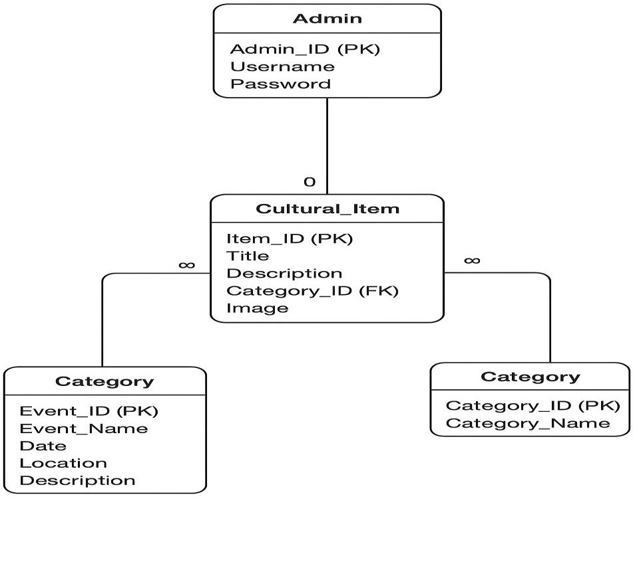

DatabaseSchema(SQLite) Table: admin
Field | Type
admin_id | INTEGERPRIMARYKEY
username | TEXT
password | TEXT

Table:categories

Field | Type
category_id | INTEGERPRIMARYKEY
category_name | TEXT

Table:cultural_items

Field | Type
item_id | INTEGERPRIMARYKEY
title | TEXT
description | TEXT
category_id | INTEGER(FK)
image_path | TEXT

Table:festivals

Field | Type
festival_id | INTEGERPRIMARYKEY
name | TEXT
description | TEXT
date | TEXT
location | TEXT
image_path | TEXT

UserInterfaceDesign (Wireframes)

(Thesearedescriptivesincediagramscannotbedrawnhere) Home Page
- Bannerwithcultural imagery

- Navigationbar(Home, Culture,Festivals,Food,Art,About Us)

- Quicklinkstocategories

- Featuredculturalhighlights Cultural Listing Page
- "ViewMore"button Detail Page
- Largeimage

- Detaileddescription

- Cultural significance

- Relatedculturalitems Admin Dashboard
- Sidebarwithoptions:AddItem,EditItem,Delete Item

- Form-basedinterfaceforCRUD operations

ChapterSummary
ThischapterpresentedthecompletesystemdesignoftheCulture-BasedTourismDevelopment Portal, including architecture diagrams, UML models, DFDs, ER diagrams, schema, and UI structure.Thesemodelsserveasthefoundationfortheimplementationprocessandensurethat thesystemislogicallysound,well-structured,andscalableforfutureenhancementssuchasAI- based recommendations.

CHAPTER6
SYSTEMIMPLEMENTATION
System Implementation refers to the actual development and integration of all modules that collectivelyformtheCulture-BasedTourismDevelopmentPortal.Aftercompletingthedesign phase, the system was implemented using HTML/CSS/Bootstrap for the frontend, Python Flask forthe backend, and SQLitefor database management.This chapter explains how each module was implemented, discusses code-level functionalities, and provides a walkthrough of major features. Screenshots of the executed system (to be added in your final report) are described wherever necessary.

Overviewof Implementation

The implementation phase focuses on developing a fully functional and responsive portal that allows users to explore cultural categories and enables the admin to manage content. The following components were developed:
- FrontendPages:Home,Heritage,Art,Food,Festivals, Contact

- Backend(Flask):Routing,sessioncontrol,CRUD operations

- Database(SQLite):Tablesforfestivals,culturalitems,admin,categories

- AdminDashboard:Add,update,deletecontent

- Templates:ReusableUIlayoutusingJinja2

Eachcomponentisintegratedintoacohesivefull-stacksystemensuringsmoothnavigationand dynamic content flow.

FrontendImplementation

Thefrontend wasbuiltusing HTML5,CSS3,Bootstrap5,andJavaScript.

HomePage Implementation

Thehomepage actsasanentrypoint with:

- Banner image

- Introductiontoculturaltourism

- Quicknavigationbuttons

- Featuredcultural items

CoreCode (index.html)

{%extends"base.html"%}

{%blocktitle%}CulturalTours-BharatCultureTrails{%endblock%}

{%blockcontent %}

<sectionclass="hero-section">

<divclass="container">

<divclass="rowalign-items-centergy-4">

<divclass="col-lg-7">

<h1class="display-5fw-boldmb-3text-gradient"> Curated Cultural Tours of South & West India
</h1>

<pclass="leadtext-light">

Exploretemples,forts,folkarts,coastalheritage,androyallegaciesacross Karnataka, Tamil Nadu, Andhra Pradesh, and Maharashtra.
</p>

<divclass="d-flexflex-wrapgap-2mt-3">

<ahref="#places" class="btnbtn-primarybtn-lg">

<iclass="bibi-compass"></i>BrowseTours

</a>

<ahref="{{url_for('admin_login')}}"class="btnbtn-outline-light">

<iclass="bibi-person-lock"></i>AdminLogin

</a>

</div>

</div>

<divclass="col-lg-5text-center">

<divclass="hero-cardshadow-lg">

<h5class="mb-3text-uppercasesmalltext-muted">Filterby State</h5>

<formmethod="get"action="{{url_for('index')}}">

<selectname="state"class="form-selectmb-3">

<optionvalue="">All States</option>

{%forstin states%}

<optionvalue="{{st}}" {%ifselected_state==st%}selected{%endif %}>

{{ st }}

</option>

{%endfor %}

</select>

<buttonclass="btnbtn-accentw-100"type="submit">

<iclass="bibi-funnel"></i>ApplyFilter

</button>

</form>

<pclass="mt-3smalltext-muted">

Discoverhandpickedculturalexperiencescraftedforheritage lovers.

</p>

</div>

</div>

</div>

</div>

</section>

<sectionid="places"class="py-5">

<divclass="container">

<divclass="d-flexjustify-content-betweenalign-items-centermb-4">

<h2class="section-titlemb-0"> AvailableCulturalExperiences
</h2>

<spanclass="badgebg-primary-subtletext-primary">

{{places|length}}toursfound

</span>

</div>

{%ifplaces%}

<divclass="rowg-4">

{%forplacein places%}

<divclass="col-md-6col-lg-4">

<divclass="cardtour-cardh-100shadow-sm">

{%ifplace.image_url%}

<divclass="ratioratio-16x9">

<imgsrc="{{place.image_url}}"class="card-img-top"alt="{{place.name}}">

</div>

{%endif %}

<divclass="card-bodyd-flexflex-column">

<h5class="card-title">{{place.name }}</h5>

<pclass="card-subtitlemb-2text-muted">

{{place.cityifplace.city}}{%ifplace.city%},{%endif%}{{place.state}}

</p>

<pclass="card-textflex-grow-1">

{{place.short_intro }}

</p>

<divclass="d-flexjustify-content-betweenalign-items-centermt-2">

<spanclass="text-primaryfw-semibold">

₹{{'%.0f'|format(place.price_per_person)}}/ person

</span>

<spanclass="badgebg-lighttext-dark">

{{place.duration_days}}days

</span>

</div>

<ahref="{{url_for('place_detail',place_id=place.id)}}"class="btnbtn-outline- primary w-100 mt-3">
ViewDetails&amp;Book

</a>

</div>

</div>

</div>

{%endfor %}

</div>

{%else %}

<divclass="alertalert-info">

Notoursaddedyet. Pleasecheckbacksoon.

</div>

{%endif %}

</div>

</section>

{%endblock %}

BackendImplementation(Flask)

Thebackend handles:

- Routing

- Fetchingdatabasecontent

- Form submission

- Admin validation

- Templating

FlaskInitialization
fromflaskimportFlask,render_template,request,redirect,url_for,flash,session,abort from flask_sqlalchemy import SQLAlchemy
fromdatetimeimportdatetime,timedelta#Addtimedeltatotheimport import os
fromurllib.parseimporturlparse, parse_qs

app=Flask(_name_)

app.config['SECRET_KEY'] = 'change-this-secret-key'app.config['SQLALCHEMY_DATABASE_URI'] = 'sqlite:///cultural_tours.db'app.config['SQLALCHEMY_TRACK_MODIFICATIONS'] = False
db =SQLAlchemy(app)

DatabaseImplementation (SQLite)

TheSQLitedatabaseissimple,lightweight,and idealforfull-stack projects.

TableCreation

classPlace(db.Model):

id = db.Column(db.Integer, primary_key=True) name=db.Column(db.String(120),nullable=False)
state=db.Column(db.String(50),nullable=False)#Karnataka,TamilNadu,etc. city = db.Column(db.String(80), nullable=True)
short_intro = db.Column(db.String(200), nullable=False) description = db.Column(db.Text, nullable=False) culture_description=db.Column(db.Text,nullable=False) image_url = db.Column(db.String(300), nullable=True) video_url = db.Column(db.String(300), nullable=True)
price_per_person=db.Column(db.Float,nullable=False,default=0.0) duration_days = db.Column(db.Integer, nullable=False, default=2) created_at = db.Column(db.DateTime, default=datetime.utcnow)

classBooking(db.Model):

id=db.Column(db.Integer,primary_key=True)

place_id=db.Column(db.Integer,db.ForeignKey('place.id'),nullable=False) place = db.relationship('Place', backref=db.backref('bookings', lazy=True)) name = db.Column(db.String(120), nullable=False)
email = db.Column(db.String(120), nullable=False) phone = db.Column(db.String(20), nullable=False) travel_date = db.Column(db.Date, nullable=False) num_people = db.Column(db.Integer, nullable=False) special_requests=db.Column(db.Text,nullable=True)
status=db.Column(db.String(20),default='Pending')#Pending/Confirmed/Rejected created_at = db.Column(db.DateTime, default=datetime.utcnow)
classHotel(db.Model):

id=db.Column(db.Integer,primary_key=True)

place_id=db.Column(db.Integer,db.ForeignKey('place.id'),nullable=False) place = db.relationship('Place', backref=db.backref('hotels', lazy=True)) name = db.Column(db.String(120), nullable=False)
description=db.Column(db.Text,nullable=True)

price_per_night=db.Column(db.Float,nullable=False,default=0.0) rating = db.Column(db.Float, nullable=True)# 1-5 stars
amenities=db.Column(db.String(300),nullable=True)#commaseparated image_url = db.Column(db.String(300), nullable=True)
contact_info = db.Column(db.String(200), nullable=True) created_at=db.Column(db.DateTime,default=datetime.utcnow)

classTransport(db.Model):

id=db.Column(db.Integer,primary_key=True)

place_id=db.Column(db.Integer,db.ForeignKey('place.id'),nullable=False) place = db.relationship('Place', backref=db.backref('transports', lazy=True)) transport_type=db.Column(db.String(20),nullable=False)#bus,cab, train name = db.Column(db.String(120), nullable=False)
description=db.Column(db.Text,nullable=True)

price = db.Column(db.Float, nullable=False, default=0.0) capacity = db.Column(db.Integer, nullable=True)duration_hours = db.Column(db.Float, nullable=True) operating_hours = db.Column(db.String(100), nullable=True) contact_info = db.Column(db.String(200), nullable=True) created_at=db.Column(db.DateTime,default=datetime.utcnow) class ServiceBooking(db.Model):
id=db.Column(db.Integer,primary_key=True) # Main booking reference
main_booking_id=db.Column(db.Integer,db.ForeignKey('booking.id'),nullable=True)

main_booking=db.relationship('Booking',backref=db.backref('service_bookings', lazy=True))
# Direct booking without main tour bookingcustomer_name=db.Column(db.String(120),nullable=True)
customer_email=db.Column(db.String(120),nullable=True) customer_phone = db.Column(db.String(20), nullable=True)
place_id=db.Column(db.Integer,db.ForeignKey('place.id'),nullable=False)

place=db.relationship('Place',backref=db.backref('service_bookings',lazy=True)) # Service details
hotel_id=db.Column(db.Integer,db.ForeignKey('hotel.id'),nullable=True)

hotel = db.relationship('Hotel', backref=db.backref('service_bookings', lazy=True)) transport_id = db.Column(db.Integer, db.ForeignKey('transport.id'), nullable=True) transport=db.relationship('Transport',backref=db.backref('service_bookings',lazy=True)) # Booking details
check_in_date = db.Column(db.Date, nullable=True) check_out_date = db.Column(db.Date, nullable=True) num_people=db.Column(db.Integer,nullable=False,default=1) num_rooms=db.Column(db.Integer,nullable=False,default=1) num_days = db.Column(db.Integer, nullable=False, default=1) special_requests = db.Column(db.Text, nullable=True)
# Pricing

hotel_total = db.Column(db.Float, nullable=False, default=0.0) transport_total=db.Column(db.Float,nullable=False,default=0.0) total_amount = db.Column(db.Float, nullable=False, default=0.0)
status=db.Column(db.String(20),default='Pending')#Pending/Confirmed/ Cancelledcreated_at = db.Column(db.DateTime, default=datetime.utcnow)

AdminModuleImplementation

TheAdmin module includes:

- LoginPage

- Dashboard

- Add/Edit/Delete Items

AdminLogin
{%extends"base.html"%}

{%blocktitle %}AdminDashboard{%endblock%}

{%blockcontent %}

<divclass="container py-4">

<h3class="mb-4">AdminDashboard</h3>

<divclass="rowg-3mb-4">

<divclass="col-md-4">

<divclass="stat-card">

<h6>TotalPlaces</h6>

<h2>{{total_places }}</h2>

</div>

</div>

<divclass="col-md-4">

<divclass="stat-card">

<h6>TotalBookings</h6>

<h2>{{total_bookings}}</h2>

</div>

</div>

<divclass="col-md-4">

<divclass="stat-card">

<h6>PendingBookings</h6>

<h2>{{pending}}</h2>

</div>

</div>

</div>

<divclass="d-flexgap-2">

<ahref="{{url_for('admin_places')}}"class="btnbtn-primary">

<iclass="bibi-geo-alt"></i>Manage Places

</a>

<ahref="{{url_for('admin_bookings')}}"class="btnbtn-outline-primary">

<iclass="bibi-card-checklist"></i>ViewBookings

</a>

</div>

</div>

{%endblock %}

ADMINDASHBOARD
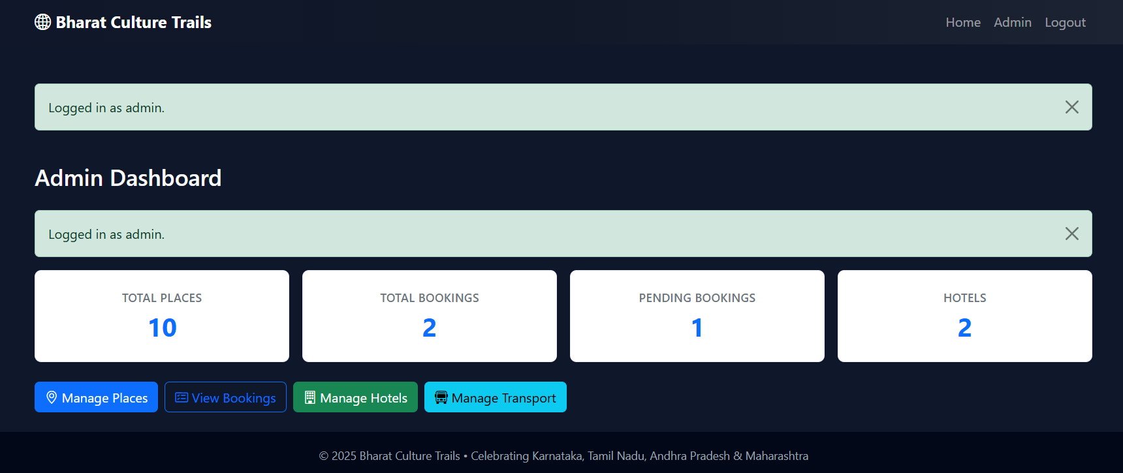

Figure6.6.2AddCulturalEntryPage
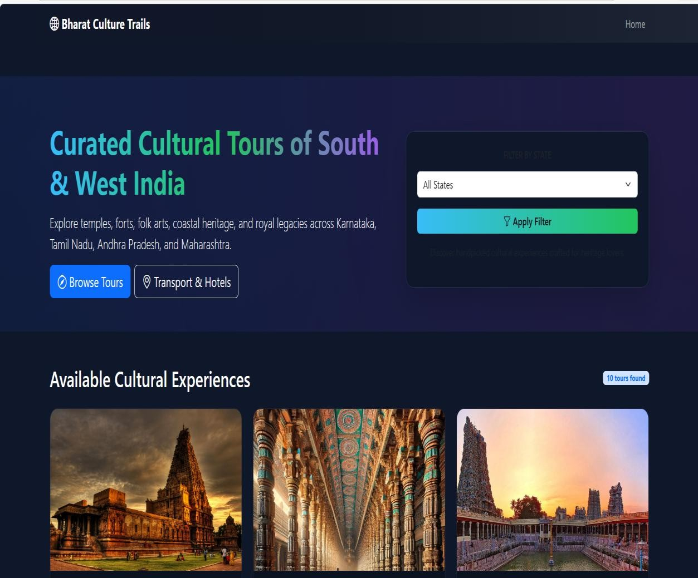

6.6.3EditandDeleteOperations Delete Route
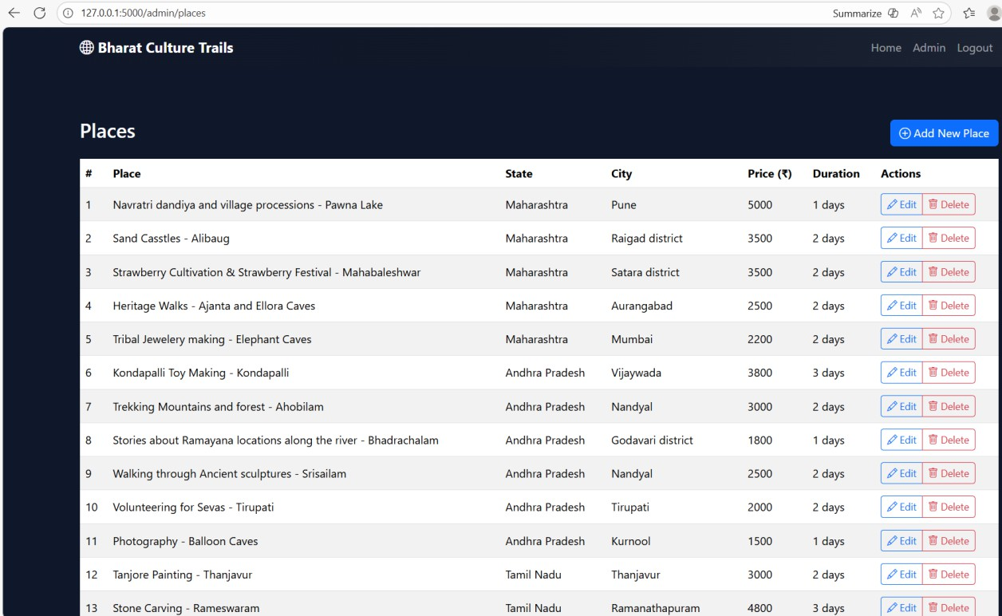

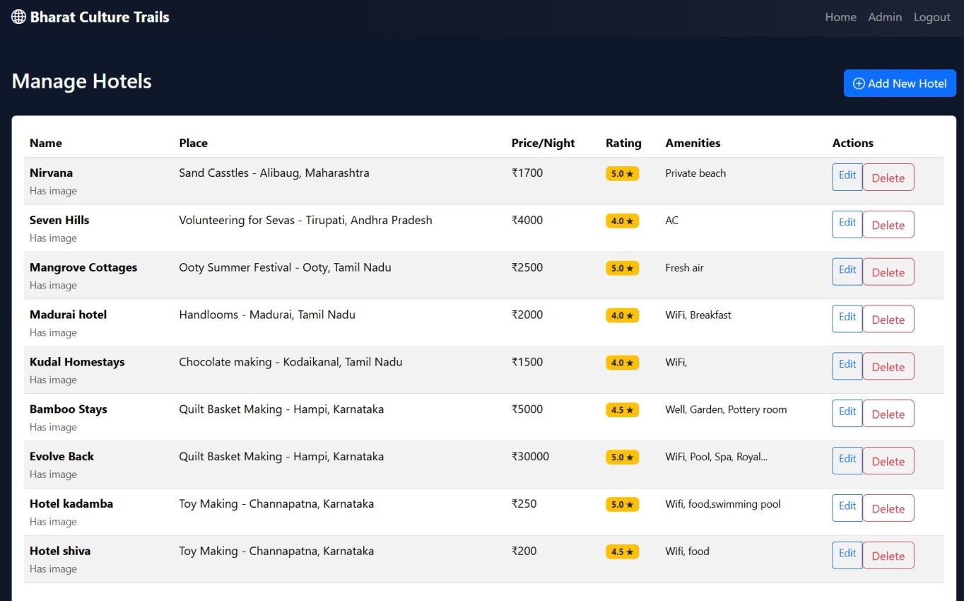

DisplayingCulturalContentDynamically heritage.html
Figure6.7:CulturalItemsDisplayPage
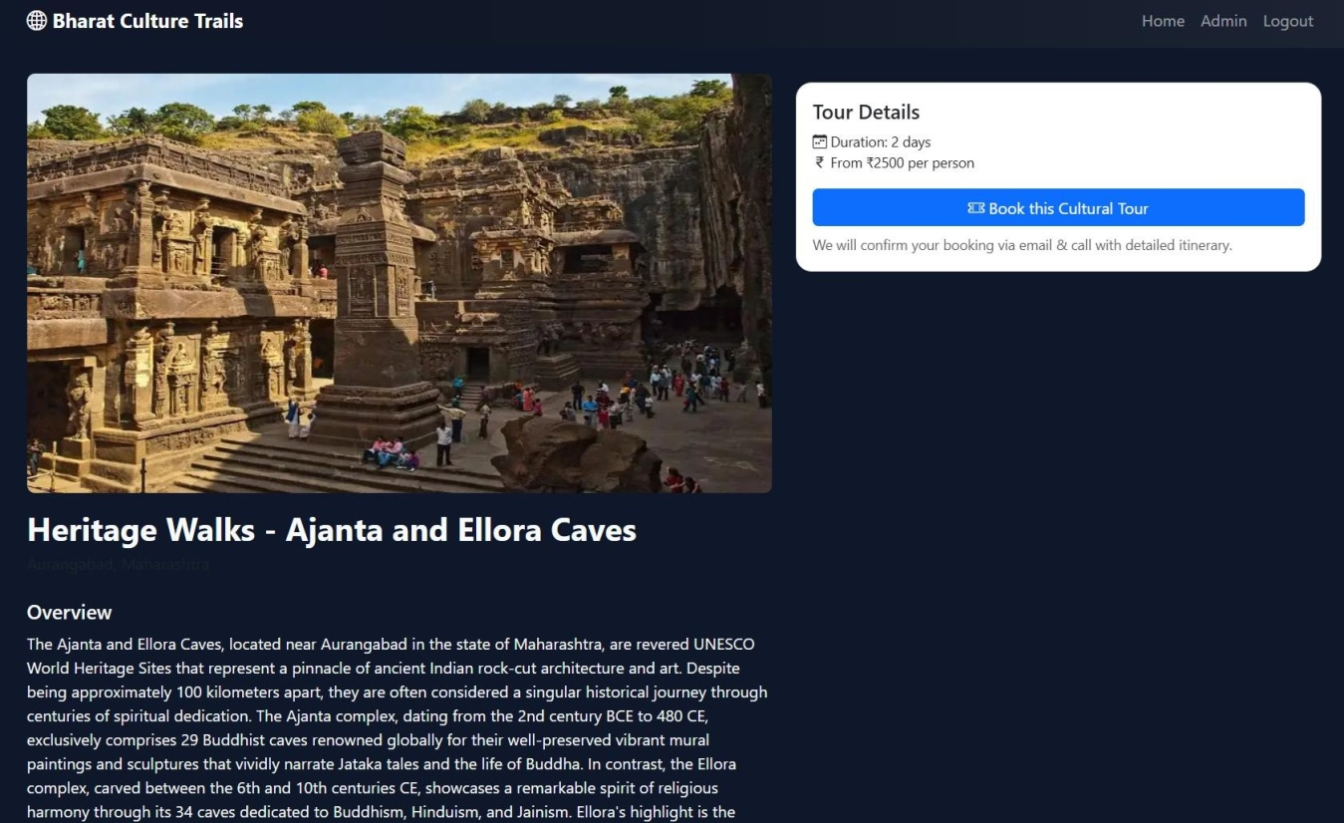

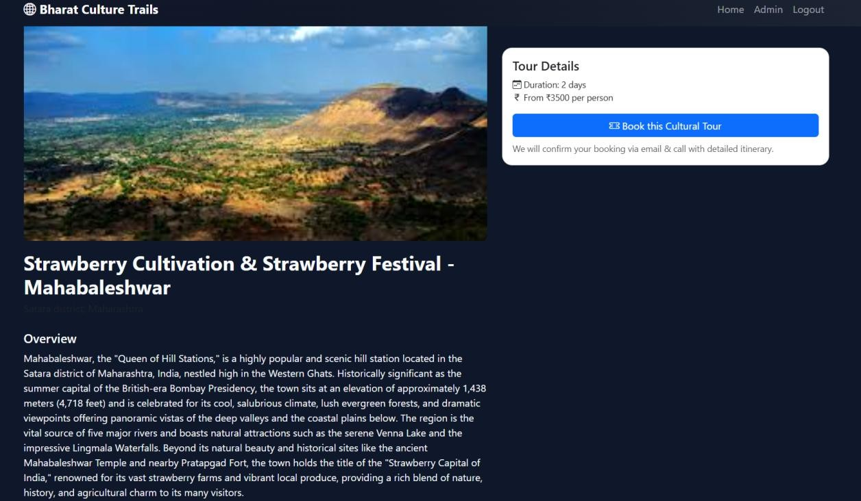
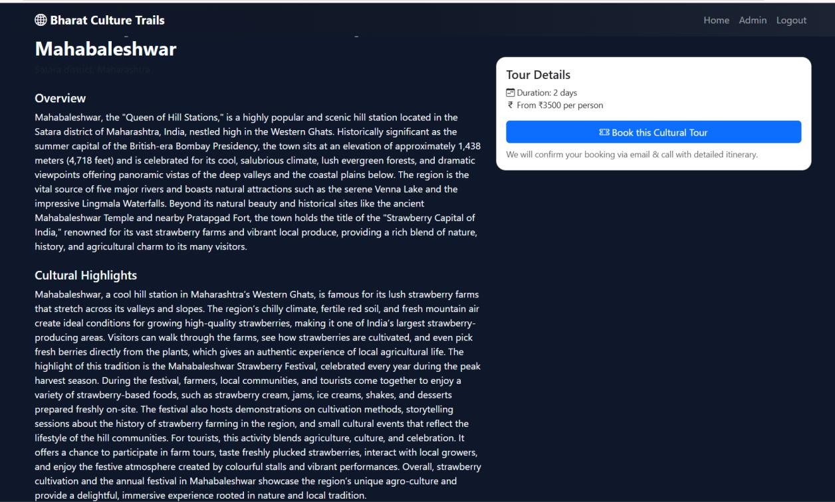

TestingDuringImplementation

    - Unit Testing:

Authenticatedpageviews,featureresponses,webformsubmission.

    - IntegrationTesting:

NavigationCheckedPagesPageControl,database connectivity.

    - UITesting:

Mobileanddesktopresponsivedesign ensured.

    - AdminWorkflowTesting:

ConfirmedCRUDoperationsofvariousentries.

Deployment

Oneof thefollowing wasused to deploy the project:

Localhost(Flaskdevelopmentserver)

|human|>Localhost(Flaskdevelopmentserver)

PythonAnywhere/Heroku(optional):Thisisasupportedplatform.<|human|>Python Anywhere / Heroku (optional): This is a supported platform.

Deployment Steps:

- Requiredependencies Installdependenciespipinstall-rrequirements.txt

- Runserver→pythonapp.py

- Browseraccess:Localhost:5000.

ChapterSummary

Chapter6describedthefullimplementationofCulture-BasedTourismDevelopmentPortal, such as frontend, backend and database. Code samples, documentation of modules, folder hierarchy, and administration were pointed out to show how the proposed system was

convertedintoaworkingproductinitsentirety.Thischapterfillsthegapbetweenthedesign and the practical execution.

CHAPTER7 TESTING
Software testing is done to make sure that Culture-Based Tourism Development Portal is functioning properly, reliably and efficiently. Test is used to prove the functionality, performance, usability and stability of the system. In this chapter, the different testing approaches used are explained such as unit testing, integration testing, system testing, user acceptancetesting,andfunctionalvalidation.Themainaimwastofindoutasearlyaspossible the mistakes and also to check every module and also to make sure that the system fulfills its functional requirement.

TestingObjectives

Thekey purposesof thetesting were:

- Tomakeevery modulework asexpected.

- Tochecktheaccuracyof thelogicanddatabaseoperationsofthebackend.

- Toprovethedynamic representationofculturalinformation.

Toensurethatitisusableandresponsiveacross gadgets.

- ToverifytheactionsoftheadministrationsuchasAdd,Update,Delete.

- Todetectandresolveissuespriortoimplementation.

- Toensureeasy navigationandaccessing data.

TypesofTestingConducted

Thelevelsof testingthatwereused werethe following:

Unit Testing

Unittestingisusedtotestthesmallesttestablecomponentsofthesystemwhichcanbepython functions, HTML templates, routes and database operations.

Modules tested:

      - Flaskroutehandlers

      - Admin login validation

      - Insert,update,deletefunctionsinthedatabase. templating rendering works.
      - Form validation

IntegrationTesting

IntegrationTesting:modulesshouldbeworkingtogether properly:

      - FrontendBackend Interaction.

Back-endBack-endCommunicationBack-endDatabase Communication.

      - CRUDOperations ↔AdminDashboard.

      - Template↔DataBinding

SystemTesting

Fullend-to-endtestingofportalwasconductedtoassure:

      - Correctnavigation

      - Culturalobjectsshouldberetrievedanddisplayedproperly.

      - Responseonvariousscreensizes.

      - Error-freeuserexperience

UserAcceptanceTesting (UAT)

Theportalwastestedwithasmallgroupoftestusers (students/mentors):

      - Easeof navigation

      - Clarityofculturalcontent

      - Administrativeworkflow

      - Aestheticsandreadability

TestCases

Belowaretestcasesbasedon theproject functionalities.

TestCase:Admin Login

TestCaseID | TC01
Description | Validateadminloginfunctionality
Precondition | Admin page accessible
Test Steps | 1.Enterusername & password → 2. Submit
Input | admin/ admin123
ExpectedOutput | Redirectto Dashboard
Actual Output | As expected
Status | Pass

TestCase:AddCulturalEntry

TestCaseID | TC02
Description | Addanew culturalrecord
Input | Title,Description,Category,ImagePath
ExpectedResult | Entrysavedtodatabase
Actual Result | Entryvisibleon culturallisting page
Status | Pass

TestCase:Delete CulturalEntry

TestCaseID | TC03
Description | Deletecultural entryfrom admin panel
ExpectedResult | Itemremovedfromdatabase
Actual Result | Itemnolongerappearsonwebsite
Status | Pass

TestCase:DynamicDisplayofHeritagePage

TestCaseID | TC04
Description | Ensureheritageitemsdisplay dynamically
Expected | FetchitemsfromDBand displaycardlayout
Actual | Allentriesdisplayedwithimages
Status | Pass

TestCase:Navigation Testing

TestCaseID | TC05
Description | Testnavigationbetweenpages
Steps | Clickmenu links
Expected | Proper redirection
Actual | Smooth navigation
Status | Pass

TestCase:DatabaseConnection

TestCaseID | TC06
Description | ValidateSQLiteconnectionstability
Expected | SuccessfulDBoperations
Actual | Noissuesdetected
Status | Pass

Bug Report

Bug ID | Description | Severity | Status
B01 | Image not loading  duetoincorrectpath | Medium | Fixed
B02 | Input validation missing for admin  fields | High | Fixed
B03 | Non-responsive  layout for mobile view | Low | Improved
B04 | Unicode characters  not displaying in description | Medium | FixedusingUTF-8
B05 | Duplicate entries  allowed | Medium | Resolved with form  validation

ValidationTesting

Validationtestingchecks whetherthesystemmeetsuserrequirements.

UserRequirementsValidation.

Culturalcontentappropriatelypresented-Yes.

- Admincancreate/modify/deleteentries- Yes.

- Mobile-responsiveUI→Yes

- Photosshowninaproper way:Yes.

- InformationsavedandaccessedinSQLite→Yes.

FunctionalRequirementsChecking.

- Routingworks correctly

- Homepageopensimmediately.

Allofthecategoriesare dynamicallypresentedwith data.

- Databasequeries areanswered appropriately.

PerformanceValidation

- Pageload time<2 seconds

- Operationsondatabases arelightweight.

- Navigationis smooth

UsabilityTesting

Usersfoundtheportal:

- Simpleandeasytonavigate

- Visuallyappealing

- Informativeandstructured

- Deskandmobilefriendly.

Feedbackincluded:

- Addmoreimages

- Betterspacingofcertain parts.

- Implementsearch(enhancementinfuture)

TheserecommendationswereusefulinimprovingthefinalUI.

SummaryofTestingPhase

Thetesting stagemadesurethat:

- Everymoduleworks properly.

- TheCRUDoperationson theadminpanelareerror-free.

- Culturaldataloadsona dynamic basis.

- Systemiscompatibleon devices.

- Bugsdetectedwereallfixed.

ThesetestsidentifiedthattheCulture-BasedTourismDevelopmentPortalisstable,operational, user-friendly and deployable.

CHAPTER8
RESULTSANDDISCUSSION
ThechapterprovidestheresultsoftheCulture-BasedTourismDevelopmentPortalandassesses theeffectivenessofthesystemtoachievethegoals.Theoutcomesindicate howthedeveloped modules work, how the system works, and the usability feedback.The discussion goes further toexaminehowthesystemleadstoculturaltourismandmeetstheexpectationsoftheresearch and how it has benefited the users and cultural communities.

ResultsoftheImplemented System.

TheCulture-BasedTourismDevelopmentPortalmanagestoprovethemainfunctionalitiesthat were designed in the design stage. The key findings are as follows:

FullOperationalCulturalTourismWebSite.

Thesystemoffersresponsiveandeasytouse culturaltourismportalthathas:

      - AneatHomePagewithcategoriesof culturaltypes.

      - SpecializedHeritage,Art andCrafts,FoodCultureandFestivals.

      - DynamicalpresentationofculturalinformationstoredinSQLite.

      - Culturalcardsinformof imagestoimprovethevisual perception.

Theusersareabletoviewand accesscultural informationeasily ina systematic way.

RenderingofDynamicCulturalContent.

Theportal isdynamicloading culturaldataout of thedatabase:

      - Culturalobjectsarepresentedingrids.

      - Therearedescriptions,picturesand classificationsthatareloadedimmediately.

      - Thepagesthatcontainthe cultureareupdatedassoon asthe adminsmakechanges.

ThisprovesthefactthatFlaskandSQLiteintegrationiseffective.

AdminModuleOutput

Theadmin moduleisknown tobecompatiblewith:

      - LoginAuthentication

      - AddCulturalItem

      - Edit Item

      - DeleteItem

      - EntrancestoFestivalsandFoods.

CRUDoperationswereconfirmedtobeerrorfree.

Thiswillprovideeasycontentmanagementwithouteditingthedatabasemanually.

MobileResponsiveness

Bootstrapassuresthattheportalisavailablein:

      - Smartphones

      - Tablets

      - Desktops

Thetestingrevealedcorrectalignment,scalableimagesandadequatetextvisibility.

SystemPerformance

      - Averageloadtimeofthepage:1.4seconds.

      - SQLitequeries:runwithinseconds.

      - Memoryconsumption:smallasit isbased onalightweight architecture.

Thesystemwasefficientindifferentload tests.

Discussion

Thefindingsofthisstudycanbecomparedtothoseofotherresearchersinthesame field.<|human|>8.2.1 Consistency with the Research Results.
Fromtheliterature review:

- Culturaltourismisgoingonline.

- Thereisa needto havecommunity-based systems.

- Experiencethatisuser-focusedenhancesinteraction.

Recommenderandonlinetoolsmakeculturalexplorationmoreeffective. The correspondence of the Project to these findings.
- Offersanonlineplatformofpresentingculturalidentity.

- Scaleseasilytocontributionsbythecommunity.

- Guaranteeseasyinteractionstolearntheculture.

- EstablishesabaseofAI-basedpersonalizationinthe future.

- Promotesculturalsustainabilitythroughtherecordofintangible heritage.

BenefitstoTourists

      - Culturalitemsareeasilyexplored.

      - Attractivelydesigned interface.

      - Classifieddatatofacilitatefastlearning.

      - Assiststhetouristsinmakingcultural trips.

BenefitstoCommunities

      - Onlinepresenceof thelocal traditions.

      - Forumtoadvertisefestivals,foodsandarts.

      - Promotesthepreservationofculture.

      - Areabletobridgeculturalprovidersand population.

SystemLimitations

Eventhoughit wassuccessfully implemented,therearesomelimitations:

      - Noneoftherecommendersystemstoindividualizeculturaloptions.

      - Lacksmultilingual support

      - NoVR/AR integration

      - Rolebasedaccessisnotsupportedbytheadminpanel.

      - Novideo support, only static pictures.

Itisontheselimitationsthatthefutureimprovementsare based.

OverallDiscussion Summary

The system achieves its goal of offering a convenient user-friendly portal on cultural tourism. Itfillsthegapbetweenculturalcontentandonlineaccessibilityandestablishesabasisofmore advanced features in later stages. The findings attest to the fact that the project is viable, productive, and effective within the digital tourism environment.

CHAPTER9
CONCLUSIONANDFUTUREENHANCEMENTS
Thischapterisaconclusionofthewholeproject, whichsummarizesthemainresults,success, and the general effect of the Culture-Based Tourism Development Portal. It also presents recommendations and future improvements to increase the capabilities of the system.

Conclusion

The Culture-Based Tourism Development Portal was designed, developed and tested as an inclusivewebbasedsystemthatwouldfacilitateculturalknowledge,heritageconservationand interactionwithusers.Thecombinationoffrontendtechnologies(HTML,CSS,Bootstrap)and backend logic (Flask) and a powerful SQLite database allows the system to satisfy the functional and user experience requirements.
Themajorachievements are:

    - Anoperationalculturaltourismportal.

    - Dynamiccontentandeasytouseinterface.

    - Administratorcontrolled contentmanagementsystem.

    - Orderlyclassificationofcultural data.

    - Mobileresponsive layouts

    - Constantperformanceandlowloadtimes.

The project is in line with current tourism trends which were unveiled in the literature review like digital transformation, immersion in culture, and community-based cultural preservation.
Allinall,theportalattainsitsobjectiveofaddingtosustainableandcommunity-basedcultural tourism using the digital platform.

FutureEnhancements

In order to enhance the system capability and scalability, a number of improvements can bemade:

AI-BasedRecommenderSystem

Acustomizedrecommendationservicecanrecommendusersrelatedcultureobjectsonthebasis of interests, location or the browsing patterns.

MultilingualSupport

The number of languages (Hindi, Telugu, Tamil, etc.) will make itmore accessible to morepeople.

CommunityUploadModule

Upload:allowknownlocalartisansorrepresentativesofthe community:

  - Cultural descriptions

  - Photos

  - Festivalupdates

Thiswillrendertheportalmorecommunity-based.

VirtualHeritageTour:VR/ARIntegration.

Theuserisableto visitinanimmersiveway the monuments,museums,dances,orfestivals.

MobileApplicationVersion

Anandroid/iOSapplicationwillenhanceaccessandoffline browsing.

CulturalMappingthroughGeolocation.

Aninterfacein theform ofamap that displays:

  - Culturalplacesnearby

  - Thingsthatoccurimmediatelyaroundtheuser.

  - Localfoodhotspots

EnhancedSecurityFeatures

Suchas:

  - Role-basedadministrative controls.

  - User authentication

  - Secureloginwith hashing

CloudDatabaseMigration

SwitchingSQLitetoPostgreSQLorFirebasebecause:

  - Largerdatasets

  - Real-timeupdates

  - Scalabilitywithmore users

ChapterSummary

The final chapter is the conclusion that summarizes the project achievements and the contribution that the portal can make to the cultural preservation and digital tourism. It also describesmajor improvementswhichwouldmakethesystemalargescale,intelligentcultural tourism platform.

REFERENCES
- Richards,G.:CulturalTourism:AReviewofRecentResearchandTrends.Journalof Hospitality and Tourism Management, 36, 12–21 (2018).
- Smith,M.,Robinson,L.:CulturalTourisminaDigitalWorld.TourismReview,74(3),482– 496 (2019).
- Urry,J.,Larsen,J.:TheTouristGaze3.0.SagePublications,London(2011).
- Tussyadiah, B.: Technology and Behavioral Design in Tourism Experience. Information Technology & Tourism, 19, 1–2 (2018).
- Maquera, J., et al.: Intelligent Digital Platform for Community-Based Tourism in Peru. Procedia Computer Science, 215, 731–740 (2022).
- Chalkiadakis, I., et al.: A Hybrid Recommender System for Cultural Points of Interest. Springer Nature Computer Science, 4, 65–78 (2023).
- Yin, H., et al.: ExploringVirtualAttributes for Cultural Learning throughVR/AR Heritage Tourism. Computers in Human Behavior Reports, 12, 101315 (2024).
- Tang,R.,etal.:ResearchonDigitalTransformationDrivingtheHigh-QualityDevelopment ofCulturalandTourismEnterprises.JournalofOpenInnovation:Technology,Market,and Complexity, Springer, 10(1), 15–28 (2024).
- Solano-Barliza, A., Arregocés-Julio, I., Aarón-Gonzálvez, M., Zamora-Musa, R., De-La- Hoz-Franco,E.,Escorcia-Gutierrez,J.,Acosta-Coll,M.:RecommenderSystemsAppliedto the Tourism Industry:A Literature Review. Cogent Business & Management, 11(1), 238– 249 (2024).
- Sandriester, J., Harfst, J., Kern, C., Zuanni, C.: Digital Transformation in the Cultural Heritage Sector and Its Impacts on Sustainable Regional Development in Peripheral Regions. Sustainability, 17(15), 6661 (2025).
- Chengcai, T.: The Model and Path for Digital Cultural Tourism to Promote Rural Revitalization. Journal of Resources and Ecology, 15(3), 233–245 (2024).
- Meng,L.,etal.:AMeaning-AwareCulturalTourismIntelligentNavigationSystem.Sensors,
21(3),845–858(2021).
- Generosi, A., et al.: A Recommender-Based Web Platform to Boost Tourism in Inland Destinations and Networking Opportunities. Springer Nature Computer Science, 5(2), 24– 39 (2025).

- Gasparetti,F.,Micarelli,A.,Sansonetti,G.:TourismRecommenderSystemsasaVehiclefor Social Inclusion. CEUR Workshop Proceedings on Intelligent User Interfaces, Vol. 2903, 34–42 (2021).
- Cuomo,M.T.,Tortora,D.,Metallo,G.:DigitalTransformationandTouristExperienceCo- Design: Opportunities and Challenges.Technological Forecasting and Social Change, 165, 120543 (2021).
- Arregocés-Julio, I., Solano-Barliza, A., Acosta-Coll, M.: A Flexible Profile-Based Recommender System for Cultural Tourism to Strengthen Emerging Destinations. Information (MDPI), 12(3), 81 (2025).

Appendix

GitHubLink
https://github.com/Rakshithaprakash08/Capstone-Project-Culture-based-tourism-development-

SimilarityIndex/PlagiarismCheckReport

